Adriana’s Facebook Group Chat — Ethiopia Updates
Sunday, March 8th — Conversation begins at 0750
  Adriana Vera | Hi everyone!  I've been having a hard time with emails. I thought I sent a few out, but found them sitting in my outbox today.  It's Sunday afternoon here and I am headed off to the airport shortly to fly north to a city called Mekele where I will be visiting two of my projects. I will have to drive 2.5 hours still from Mekele though to get to them!!  I am traveling with my colleague here at the embassy, Selam. She is Ethiopian but has been working at the embassy for many years. She's great!!
  Natalia Anna | Safe travels, I just got your email with pictures! That lion is gorgeous!
Adriana Vera | I feel like I have to tell you about the Ramada hotel's buffet breakfast!! Hahaha. Small things!  You did get the email with the lion?! Wow! Great!!!
Natalia Anna | Yep
Adriana Vera | I am happy!!!
Natalia Anna | Don’t tell me about the buffet. I haven’t done my groceries yet and I’m hungry as hell. It’s only 7 AM here or rather 8 AM with the time change.
Adriana Vera | The breakfasts here at the hotel are pretty great. They have all the amazing breakfast stuff like bacon, eggs (however you want), pastries, fruit (although i don't eat this), toast, mini burgers (yes please) yoghurt, and even vegan cinnamon rolls (they're fasting here already, so this is considered fasting food I think).
Adriana Vera | Sorry!!!  And all the coffee. All the time. I might be surviving on coffee to be honest. Yesterday’s adventure around the city was pretty sobering. But it was great!  I saw their traditional Ethiopian market, their main market, Unity Park, the National Museum, a local restaurant, the Soviet monument, and of course, the leather market.  Here are some photos with descriptions:
 | 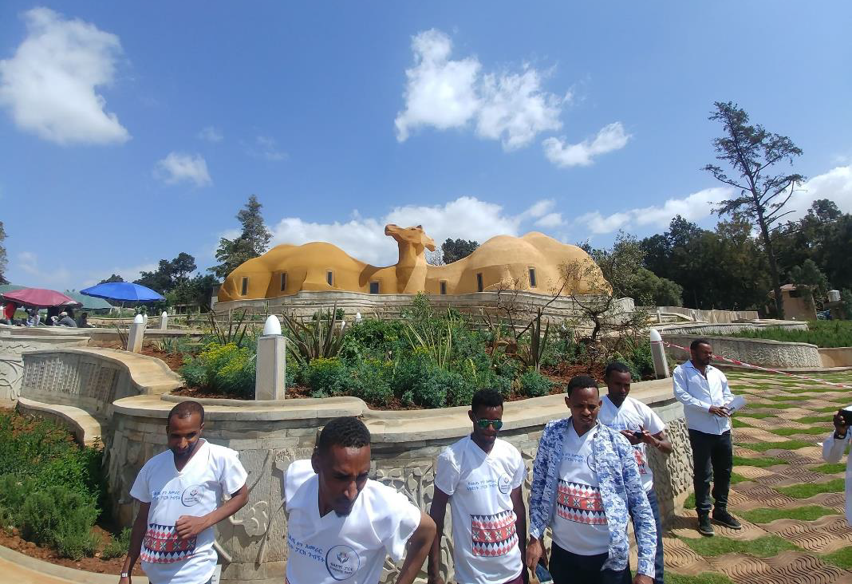
Natalia Anna | Mini burgers?
Adriana Vera | Unity Park: these people are from the south (Snnpr Region) and PM Abiy recently invited them to come to Addis and see the city. I'm pretty sure I was their first white person.  They all took pics with me. Like 30 pics. So somewhere, I am on all of these Ethiopians Facebook sites.  And of course, the tortoises who live at the museum and the museum from outside. So you can see the vegetation and general state of affairs in the last pic.  They enjoyed touching me too. I hope it brought them good luck!!!
Adriana Vera | More Unity Park.
 | 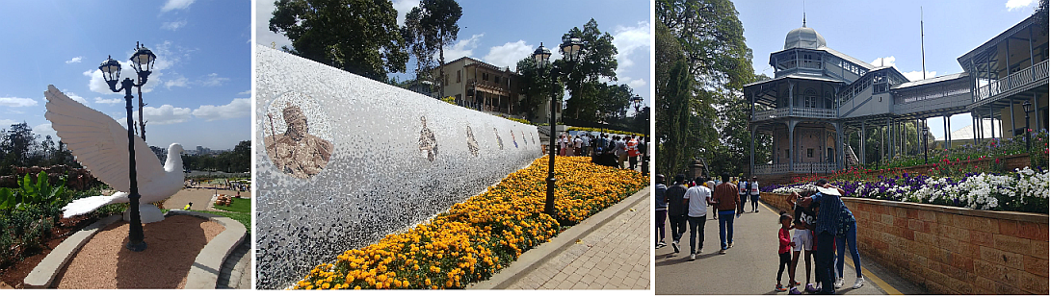
 | Unity Park Zoo inhabitants
 | 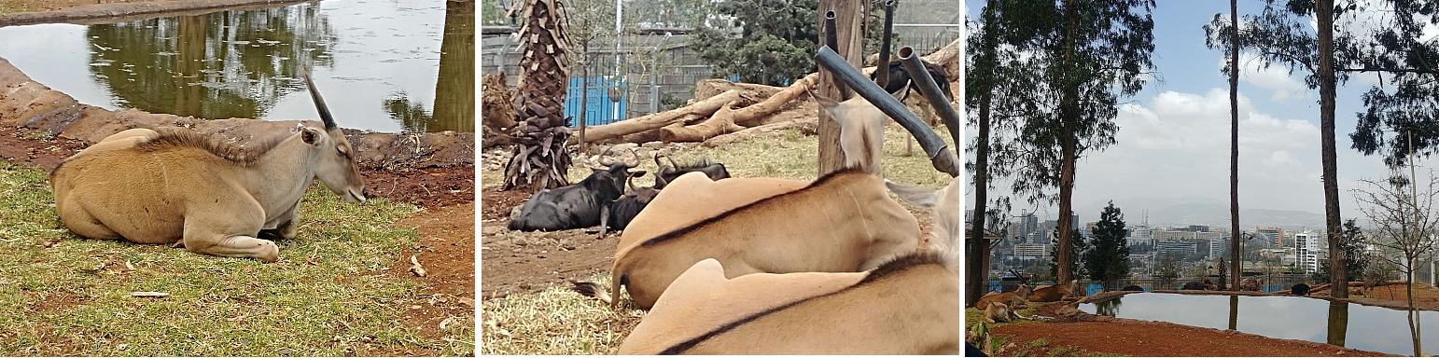
 | 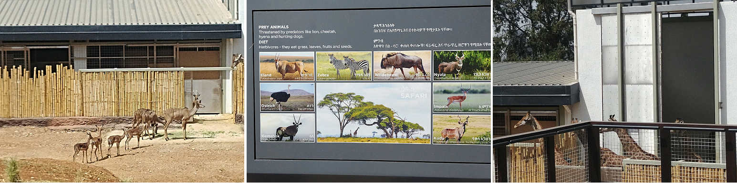
Adriana Vera | Next is the National Museum. It wasn't spectacular because I am certain that most of the national treasures of Ethiopia are in rich people's homes or have been reported with tourists who have the money but it did have all the fossil of human ancestors that were found in Ethiopia.
Adriana Vera | 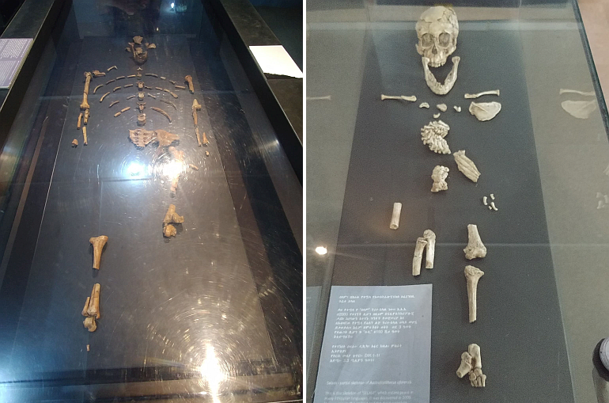
These include Lucy and Selam!
So in terms of human evolution, the museum hits the mark. They have very well translated info boards for each major period in human evolution and for animals too.
This is PM Abiys Nobel Prize. It's also housed here.
 | 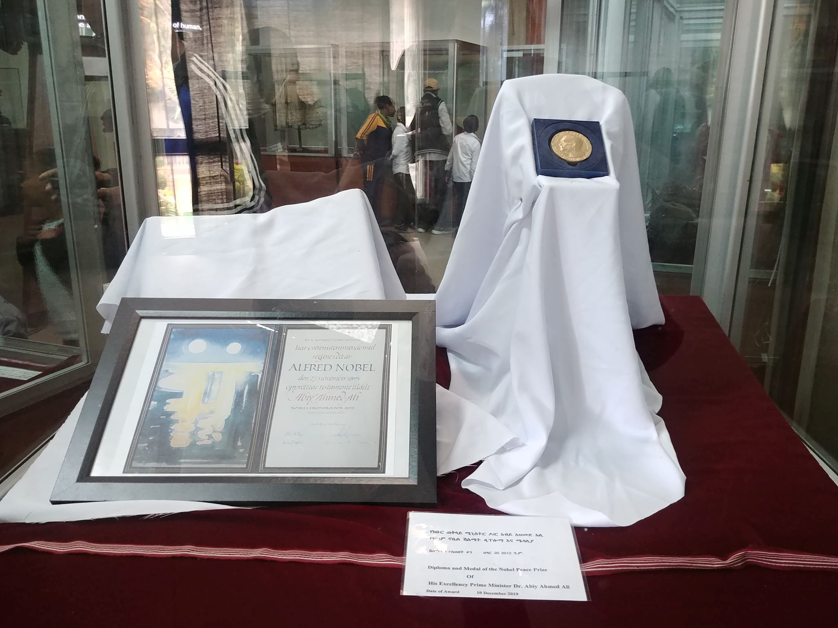
Adriana Vera | And of course, the tortoises who live at the museum and the museum from outside. So you can see the vegetation and general state of affairs in the last pic.
 | 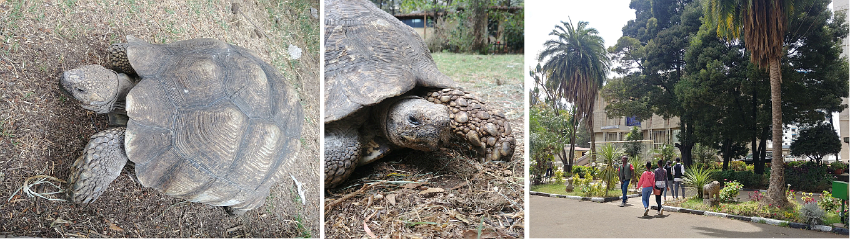
Adriana Vera | Next is the traditional open air market.  This level 7/10 chaos. Here are the factors I considered in my rating scheme: dirt road, dirt road with 1 lane for 2 directions, dirt road that is torn up and under major construction, random livestock (chicken and goats, specifically), small shops made of corrugated metal sheets, illegal sellers, random Ethiopians knocking on the car window because I'm white, total traffic chaos.  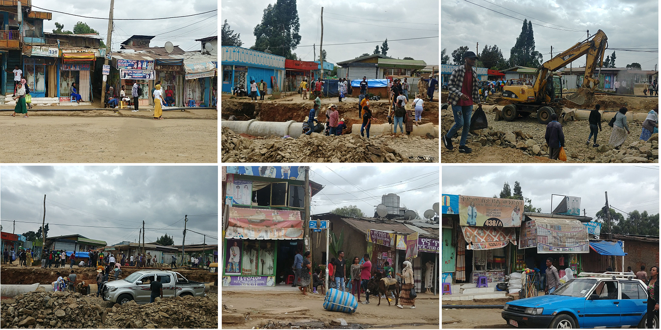
 | I forgot the donkey. There were donkeys too as indicated in my photo.
 | Gas here isn't cheap. It’s about $1 cad per litre. And because of the high elevation and low atmospheric pressure, it actually occupies a larger volume than at lower altitude so in short, they're not getting as much bang for their buck. Also, consider the age and efficiency of the old cars here.
Adriana Vera | 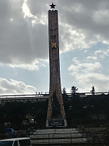  Next is the soviet monument. There was a strong relationship between the USSR and Ethiopia in the 1970s. Of course they built a monument.  I find the way government works here is still very communist. They hold on to everything and want to regulate everything rather than let the private sector in and do what the private sector is good at. But this is part of the economic reform process that Ethiopia is currently undergoing.
  Tamara Pomac | Thanks for sending these all Ad! Looks like quote and adventure! I am showing all the pictures to B too - he loved the animals!  Adriana Vera added Taras Myron to the group.
Adriana Vera | Sorry,  @Taras Myron !! I forgot you  Just for B then!! Here is the Lion King being a bit of a meanie!!!  He kicked out the Lioness!!
Adriana Vera | 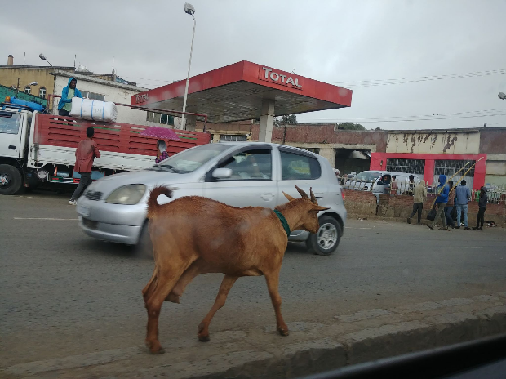  This is a random goat. She was walking with her goat friend in the middle median of the main road. I know she was a she because she was clearly pregnant with two kids. She was huge actually. I would argue that livestock and animals in general are somehow smarter in Ethiopia than they are in Canada. They just get it and are doing their thing, like going with traffic, to wherever it is they're going.
  Allison Wusaty | Adi, these are amazing pics with interesting stories. It sounds like an incredible trip with a steep learning curve. You are lucky to a part of it.  What a great reminder of how fortunate we are.
Adriana Vera | The roads here are also used by farmers and pastoralists to herd their livestock to market and the abatoires. So often, next to your car, you have a herd of cattle and their owner walking to their destination. The livestock isn't at all phased by the cars. It's pretty unbelievable!
Adriana replied to Allison | One of my colleagues from another program at Headquarters who also happened to be here told me at dinner that your first mission is the most transformative one. I can already confirm this. It has been amazing and sobering and humbling all at the same time.
Adriana Vera | Ok. Next up is their Main Shopping Market. This place was 9/10 chaos. I only docket it a point because I didn't see a herd of cattle/goats/sheep, although I did see chickens. But chickens are boring so whatever.
 | 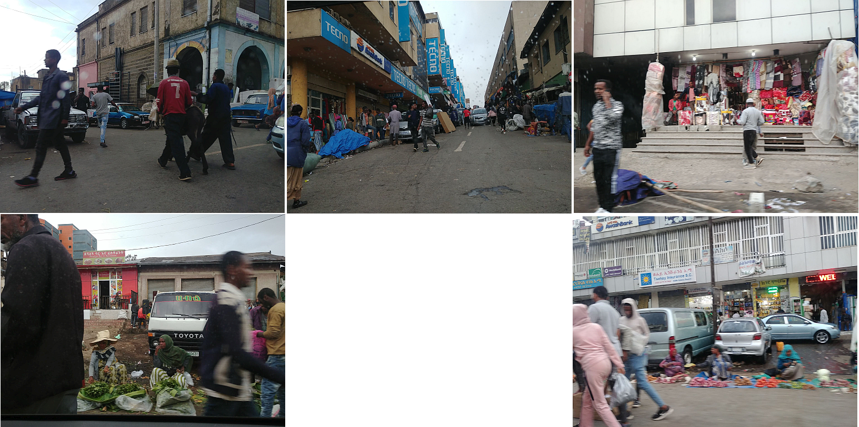
 | The women with the green leafy veg are selling chat. Chat is a drug that Ethiopians chew and get high off of. There is an entire chat section to the market. About a block in length. And allllll these women selling alllllll the chat. They're primarily Muslim as you can see, as it is spiritual or something like that. I guess you can say smoking pot is also spiritual.
Tamara Pomac | It is so hard to capture everything in pictures isn't it? Thank you for sending the thoughts as well - it is really a different world - enjoy and be careful. Gotta’ make some food for breakfast here!
Adriana Vera | Generally speaking, it is the women who sell any sort of agricultural product: spices, coffee, fresh fruit and veggies.  Also, chat is legal in Ethiopia.
Adriana Vera | Generally speaking, it is the women who sell any sort of agricultural product: spices, coffee, fresh fruit and veggies.  Also, chat is legal in Ethiopia.  The market is filled with junk from China. I can say that because from my experience, the Ethiopians agree but they say they can’t afford the better quality products so are forced to buy Chinese.  There are store fronts after storefronts after stalls of China-junk.  This Market is also divided into sections: soap, car parts, clothing, food, spices, and best of all, recycling market.  The recycling market is where they have used items and take them apart for parts or resell them. It. Is. Unbelievable. Unfortunately my photos are on my little camera. But holy moly. They have everything! Electronics, light fixtures, building materials.  This Market is also divided into sections: soap, car parts, clothing, food, spices, and best of all, recycling market.  Also, there are sections for new electronics, new building materials, furniture, you name it!!  So if your coffee maker breaks, you bring it to the recycling market and they will fix it for you!! I bet one could bring all their broken electronics from home and have them all repaired here. It's really impressive how they essentially take what we call garbage in NA, and reuse it and turn a profit on it. I am very impressed by this and their attitudes here. They really are the poorest people I have seen, yet they are managing. And they don't seem to feel sorry for themselves. They are appreciative of what they have.  $1 = 25 birr. Earlier today I ordered coffee and sparkling water to my room as I was packing. It cost me 99 birr. So $4. I gave the man who brought it up 60 birr so $2.25 and he laughed with joy and said, "Oh my gosh. Thank you miss."  His monthly salary here at the Ramada is about $28-34 cad.  I would have spent those $2.25 on something stupid at home. Like a chocolate bar or half a Starbucks coffee so giving them generous tips is so easy.  Also. I have ordered myself an early dinner and I am SO excited. HaHaHa.
Natalia Anna | Bonne appetite. I can’t wait to hear more stories like the ones you told us yesterday!
Adriana Vera | The beef tastes like kofta!!!  Shit. Who knew a burger could be so good!  I should qualify this by saying it’s not the best burger I’ve ever had, but right now, it is!!  The altitude here is another interesting thing. Addis is 7600 feet above sea level. Athletes start using supplemental oxygen at 8000 feet.  So that exercise room I was going to use here at the hotel is no longer on my itinerary. You can feel the lack of oxygen as soon as you start exerting yourself.  I am off to Mekele shortly via flight. I should be back online in 6 hours.
Tamara Pomac | Safe travels Ad!!!
Monday, March 9th — Conversation begins at 11:40
Adriana Vera | Hi everyone! I have made it to Mekele. The hotel we are staying at is the best one in the city but it's pretty dated. They've done some upgrades. Perhaps they should have focused on the stained beige carpets (and the washroom rug that is between the two beds in my room. I don't want to touch it but suspect it is hiding something) and the same shade of beige wallpaper that is starting to lift on the edges. The ceiling is however, quite impressive with a very nice crown moulding. Interesting that they focused on the ceiling, really.  Oh. This is my second room. The first one they gave me didn't have water and then it only had brown water. And it smelled of carpet cleaning chemicals. This one only has a faint smell and has clear water.
Natalia Anna | Omg. Um sleep in the sleeping bag?
Adriana Vera | Hello all! I've just come back from my first day visiting projects in the field. It was quite an experience! I am just getting ready for dinner so I will. Catch you up either later tonight or tomorrow morning before I head out on another marathon day. These are long ones. Our car picked us up at 7am and we are still going as this is a dinner meeting with the project implementing partner.
Adriana Vera | Also, the bed was probably the cleanest part of the room. They need to refocus their efforts. Lol.
Tamara Pomac | Glad to hear from you! XOXO  Sounds like quite the experience!
  Nina Pomac | This is quite a story you’re telling us! Just make sure to rest, choose your food carefully, and stay self!!! Love you!!!!
Tuesday, March 10th — Conversation begins at 1510
Adriana Vera | Hi everyone - just a quick update on my time in Mekelle and surrounding region. It was a very successful two days visiting my two projects. I have learned so much and seen so much. It's incredible. I think most notable has been our small and micro irrigation work with small holder farmers. The irrigation has made a huge difference quadrupling their production. Also, the project introduced better seed varieties which has helped too. Hearing from the individuals on how this has changed their lives because they now have a bank account and can save a bit each month so they can rent a tractor instead of using an ox plough is pretty incredible. And how they no longer have a food gap during the dry season and can buy a few ruminants and fatten them at home for slaughter during their holidays too. Pretty amazing stuff!  The tensions in that region are high at the moment. We were pulled over in a security stop by the Tigray State Police. They don't care that I'm a diplomat and "off limits" so out of the car we all go to have our passports checked and the vehicle searched. A bit sobering but all in all, not terrible.
Natalia Anna | Wow. This all sounds so interesting and a bit frightening. Keep us posted on where you go next and what you are doing.
Adriana Vera | The landscapes are amazing!!! We drove 2.5 hours through the mountains to get to one project!! They are spectacular! Covered in invasive eucalyptus, unfortunately, which is a very water intensive tree but it grows fast and meets their lumber needs. You can smell the eucalyptus in the air!
Natalia Anna | Oh wow. Clear out the lung from all the pollution?
Adriana Vera | Tomorrow I fly north east to Bahir Dar. I'll be back on Thursday evening.
Adriana replied to Natalia | Oh wow. Clear out the lung from all the pollution?  Hahaha. No cause all the clay in the air goes in your lungs with the intense dryness instead. It's a no win situation!!
Tuesday, March 10th — Conversation begins at 2200
Adriana Vera | My turn around in Addis was less than 13 hours! I arrived at about 8PM last night and am up this morning at 430 to fly out to Bahir Dar. I'll update you again this evening!!
Natalia Anna | Travel safe! Daylight savings time has been wreaking havoc on me. I’m not sleeping well at all. And I feel exhausted. I can’t imagine what you feel like travelling as much as you are.
Adriana replied to Natalia | It's all adrenaline at this point......and Ethiopian coffee!!!
Wednesday, March 11th — Conversation begins at 0130
Adriana Vera | This is one of the less pleasant parts of the trip but one that gives you a picture of the extent of the lack of infrastructure, even in cities. There is no water. Their rivers are dry, with maybe a small stream flowing because we are nearing the end of 8 months of dry season. The wet season starts May/June and lasts till Sept/Oct.  If you don't have water, you cannot do the following: wash your hands, or your face, or brush your teeth, shower, wash your clothes, etc. Brushing teeth is a big one. I am sure access to a toothbrush and toothpaste contributes to this even further.
Furthermore, Ethiopians have little appreciation for personal space so just imagine being in a conversation with an individual where some or all of the above apply. Not shaking someone’s hand is not an option either. I MUST shake their hands. Especially the subsistence farmers who Canada is supporting through my projects.
Otherwise, what I am telling them is that they are dirty and diseased and when someone is marginalized and vulnerable like these people are, that's the last thing they need to be made to feel. So lots of hand sanitizer and washing followed by another dose of sanitizer over here.
Adriana Vera | I find myself clasping my hands together just to keep them away from anything and to remind myself of the current context, etc. Another funny thing is that the kids in the rural areas who are near the road when we drive by sometimes call us Chinese!! They have A LOT of Chinese investment here. Why they think we are Chinese is beyond me though. Ha-ha.  Oh and child labour happens here. I have seen it. I saw two boys, about 13 who were helping dig the new road. Essentially, they were in the middle of the desert, all day, with shovels, digging the "edge" of the road that the excavator left behind. It was about 1.5 feet deep and hard, compacted, rocky, clayish soil. It's hard work. Back breaking. This is informal work of course, and hopefully, they will be paid for it at the end of the day. The way it works is they wait at gathering points in their small villages with any equipment they may have, hoping that they'll get picked up by the companies doing the work on their way to the job site. I have also seen children Bohdanchyk's age involved in unpaid work. For example, carrying a 5kg bag of milled grains back from the mill. These little kids just put it on their back and go. They walk along the road for hours sometimes. If they're so poor that the children are doing this work, it means they don't have a donkey even for this types of daily work.
Oh. And imagine what a squatter is like without any water. You can't imagine. Neither could I, until now. I was dry heaving in one that was in an actual hotel!!!!! This is a huge problem for women specifically. The bathrooms are horrible. They try to use them as little as possible which results in persistent urinary tract infections. Let's not even mention what life must be like if they are sick, or during other monthly events.
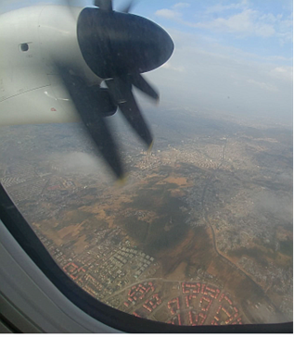
On a funny note, I'm pretty sure I peed on my shoes. I didn't even care. HaHaHa! I just needed to get the you know what out as quickly as possible!! Oh and thank god I carry my own toilet paper with me. There is none in almost all places.
Here is a pic as I take off from Addis to Bahir Dar. I hope you can zoom in and get an impression of what it is like here!!
Adriana Vera | I can't remember if I told you all this but the altitude here is quite something! 7600 above sea level. At 8000 feet, athletes start supplementing their oxygen. And for this reason, this is where allllllll the African runners train for the big marathons! When I was in Mekele, I saw quite a few out training in the early morning hours. My days start early: between 4:30 and 6am. And in Mekele, it was me, the athletes, and the mosque that were up that early!! I don't get why mosques broadcast their prayers over a loudspeaker though. Any insight???
Natalia Anna | I think they are used as alarm clocks!
Adriana replied to Natalia | Hahaha!
Adriana Vera | I have a bit of connection here in Woreda at my project visit. All is well!  Will write more later from my hotel.
  Taras Myron | Observing prayer at the correct time is a fundamental ritual for every good Muslim. The timing of the call to prayer varies slightly every day as it is based on the movement of the sun relative to earth (aka sunrise/sunset). The local mosques want to ensure as many believers as possible are praying at the right time and so - they broadcast the call to prayer 5 times every day...
Natalia Anna | That makes much more sense!
Adriana replied to Taras | Observing prayer at the correct time is a fundamental ritual for every good Muslim. The timing of the call to prayer varies slightly every day as it is based on the movement of the sun relative to earth (aka sunrise/sunset). The local mosques want to ensure as many believers as possible are praying at the right time and so - they broadcast the call to prayer 5 times every day.  I am in Bahir Dar in the Amhara Region. I have just made it back to my hotel after another 12 hour day.
Adriana Vera |   There is a lake here. It’s called Lake Tana and I am actually staying right on the lake at Blue Nile Resort  This is where I am right now!  And this is the most water I have seen since arriving!!
Natalia Anna | Is it man made? And supported by redirecting otherwise useful water from neighboring rivers and streams?
Adriana Vera | Nope! It's natural!  It may feed the Nile?
Natalia Anna | Nice
Tamara Pomac | Beautiful ad! Just signed on and saw all your messages! You are seeing parts of Ethiopia that people don't normally see. This is why missions happen and are life changing!!! We forget when we are reading reports why we do what we do - this is a reminder...amazing and a different world! Keep sending updates and stay safe ad. Xo
Adriana Vera | These pictures are from the plane. If you zoom in, you can see all the dried up river beds.
Adriana Vera | 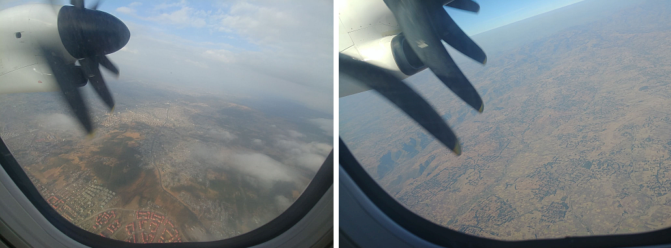
Adriana Vera | Oops! First one is Addis!!!
Nina Pomac | This is a great travelogue! What an experience this is! I hope your weekend trip is more restful and touristy!
Adriana Vera | Oh man. This morning at 5AM, i thought the entire town was praying into the loudspeaker at the Mosque!!! The echo on the lake is quite the amplifier!!!  Just heading to breakfast for a quick coffee, and then a 7am pick up to see our small and micro irrigation schemes here for stakeholder farmers!  They bring the entire farmers association to these ones so there's lots of stories and handshaking. That makes me nervous with the virus not for me but for them. They're the poor ones without access to medical assistance etc.
Thursday, March 12th — Conversation begins at 0010
Tamara Pomac | Good luck today ad! Xo
Adriana Vera | It will be a good day! This projects, SMIS, is an excellent one where the local government is involved, sees the results and scales it out to more farmers associations.
Tamara Pomac | Hope you are taking some pictures! Xo
Adriana Vera | Of course!!! But I have 2 cameras plus my phone!!
Tamara Pomac | Sonya was just up for a bit here...now I am really going to sleep. Travel safe!
Adriana Vera | So they're on my cameras!!! And I can’t plug those into my work laptop as they've blocked that.  Awwww!! Tsioms to you all! Especially B and S!!!
Tamara Pomac | Looking forward to seeing when you get home.
Adriana Vera | (Through a glass wall???)  I’m making terrible CoVid19 jokes.  I'm pretty sure I will be asked to work from home at this rate.
Tamara Pomac | Ha-ha! Bad joke. Fingers crossed. Trump just banned any travel from Europe to USA as of Friday.
Adriana Vera | I know. I saw. How come HR isn't addressing his previous MORONIC statement of how it's a flu and it'll be gone in a few weeks???
Tamara Pomac | Probably. I think that the whole from department is trying to figure out how to address travel. Did you see that one case of a man who tested positive and went to PDAC?
Adriana Vera | One of my friends from Uni and her family are American and have been told to go into isolation. Someone is sick....
Adriana replied to Tamara | I did! And PM was there. Holy moly.
Tamara Pomac | Ugh.
Adriana Vera | Even Ukraine has testing kits and is testing.  I read that in the morning you should breathe in and hold your breath for 10 Mississippi's. If you feel no discomfort or pain, you're ok. If not, go to the doctors.
Tamara Pomac | Yup. Crazy. Ok dobranich for real. Apparently the US has only tested 5000 people total while South Korea is testing 10000 daily. They apparently done have enough tests.
Adriana Vera | They have no tests. Exactly. Susan wasn't tested they just told her and her family to isolate.  Ok! Love you all!! Our partners SUV has arrives to pick us up!  Love you!!!
Thursday, March 12th — Conversation begins at 0645
Natalia Anna | Hey guys, just a heads up, my colleague’s husband and 2 of his colleagues were at a conference with someone who has now been diagnosed.  Neither she, nor her husband are feeling any symptoms, but I just wanted to let you know.  It’s a bit of a late morning for me, I’m just rolling out of bed and it’s already past 630. I have to shower and rush to the bus stop.
Nina Pomac | PLEASE Stay safe!!!!!
Adriana Vera | All is well here! Just at the airport leaving Bahir Dar for Addis!  Will touch base from there!
Natalia Anna | Safe travels
Adriana Vera | You bet!!  Ok. Ok. The holding your breath thing I posted earlier is not true! Be vigilant everyone!
Natalia Anna | Yep. I guessed.
Thursday, March 12th — Conversation begins at 1600
Adriana Vera | I am back in Addis now! Catching up on the news and everything happening in other continents. I feel a bit like I will be returning to a very different country on Wednesday. It’s an uncomfortable feeling.  Today was another great day in the field! I saw an irrigation canal system and diversion dam that is benefiting 350 households (averages household size is 5) of which, 71 are women heads if household.  Its impacts were very impressive! All my photos are on Nat’s nice camera so those will have to wait! But I saw one farmer who was benefiting and what he did with his land was amazing. He had oranges, was creating his own mango and avocado hybrids, two varieties of sugar cane and peppers, lettuce, tomatoes and multiple other herbs and spices.  He also took it upon himself to regenerate the land directly adjacent to the canal creating a micro ecosystem amongst other benefits.  He had a few kids who insisted on following me around. It's very cute!!
Thursday, March 12th — Conversation begins at 2200
Tamara Pomac | So interesting Ad! Enjoy the next few days. Yes things are getting crazy here. School is cancelled for two weeks after March break. Whoah!  Also PM's wife has tested positive! Whoah!  How are you?
Natalia Anna | So heads up. Sophie Trudeau was officially diagnosed this evening with COVID-19.
Friday, March 13th — Conversation begins at 0230
Adriana Vera | Oh no. This is bad. Well, we will see what happens next here.  I am on my way to Lalibela today to see the rock hewn churches and relax. My colleague Kathie Oginsky is coming with me so we will be kept in the loop from the embassy should any changes in the current situation occur.  My amazing hotel buffet has grilled eggplant and zucchini this morning. It. Is. So. Good. I can't eat fresh fruit or veg here. The water they wash it in could be dirty. So this is heaven!!!
Adriana Vera | To everyone at home, please don't be foolish. I know a good chunk of us have "Wusaty Superblood" but everyone still needs to be vigilant, especially those who are over 50. I know we are all still in our "thirties" but please, think of your family, grandchildren and children and play it safe. Very safe. Oddly enough, i feel safer here than I feel you are being there. Maybe cause I'm sanitizing my hands like a crazy woman???
Natalia Anna | Hey, I think your things came up on us really fast. At least in Ottawa. Which sounds counterintuitive since we’ve known for months that this was coming. But it just doesn’t seem like anybody is willing to be the grown-up and take a stand. Treasury Board refuses to make a federal government wide statement, the Prime Minister and his wife are now in self isolation, and everything is being pond off on the deputy ministers and ministries. None of them want to say stay home because its end of fiscal and sending people home often means that they can’t work. The same goes at the provincial level from what I’ve been told. And the municipal level. And for private sector, what are they going to take - Imagine being a restaurant in the business sector of Ottawa with no federal public service there. The financial hit they are going to take will probably close a good bunch of them. And people not going out to the movies, restaurants in general, sporting events have been canceled, all of them, pretty much, shopping for anything but the essentials…
Nina Pomac | Good morning! We are certainly in uncharted waters! We all have to be careful, including Dave and me.
Adriana Vera | Hi! I have arrived with Kathie and we are in a very nice place!  It's called Hotel Abyssinia  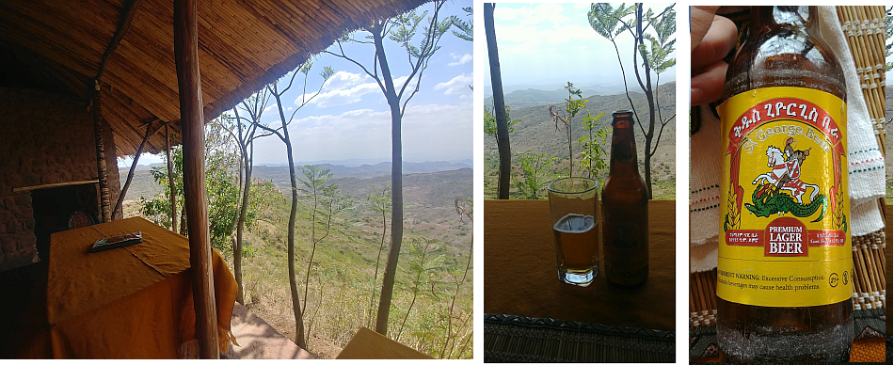
Adriana Vera | This is my view as I drink a beer with Kathie.
Taras Myron | Hi Adi... show us some photos of beer (and labels) please
Natalia Anna | Yeah. Taras is stocking up.  Just in case | . 
Adriana Vera | @Taras … I will bring you some!!!
Tamara Pomac | Beautiful!  Emoji video Bohdanchyka
Taras Myron | Nice!
Nina Pomac | St. George Beer!!!! Bring a bottle for Святого Юрія!!!!
Adriana replied to Nina | Mama - I was already planning to!!!  Everything here is St George the Slayer.  It's a bit funny really! He seems to be their favourite!
Natalia Anna | Government orders federal bureaucrats to work from home  The roughly 300,000 federal employees will be told to stay away from their offices throughout the country as long as their job allows it  ottawacitizen.com
Adriana Vera | Oops! I meant a thumbs up!
Saturday, March 14th — Conversation begins at 0330
Adriana Vera | Hi everyone! I am in Lalibela at the Old Abyssinia Hotel staying in a traditional mud hut! It is made of eucalyptus trees, then patched with grass mixed with mud and cow dung and then a skim coat of mud on top to smooth things out, and then paint, doors and windows for final touches!  Here are some pics!
 | 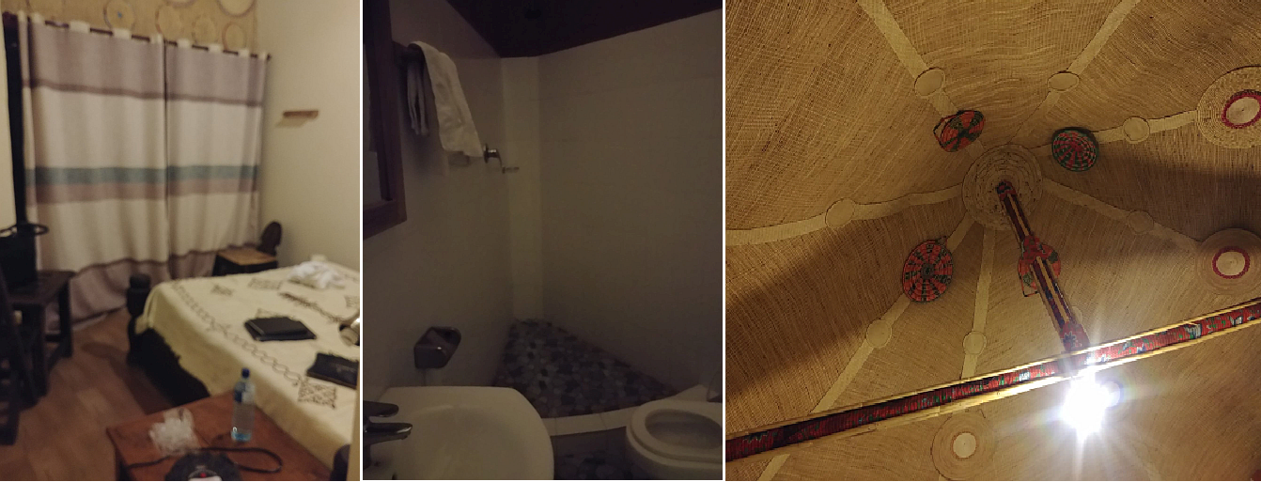
There is a bit of a fog here in Lalibela and today's flights out have been cancelled. So tomorrow, my flight will likely be impacted. Hopefully, we can fly if not tomorrow, as originally planned, then Monday!
Yesterday afternoon and this morning, I saw the rock hewn churches. They're quite impressive! They are massive. 2 or 3 stories dug down. They do this thing where they cover the floors with rugs and carpets which really impacts the beauty of the churches, in my opinion. I'd say throw those shmaty out and show off the natural beauty!! My photos are all on Nat's big camera. I will share them when I get home!
Nina Pomac | Uhhhh ... That means you’re going to have to breathe that bad air another day! Could you send a picture of the exterior of these mud huts?
Adriana Vera | More pics!!!  These are the huts! My door!
Adriana Vera | 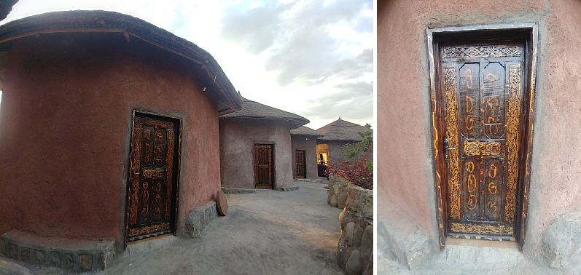
I did this today. Ha-ha. It was a quick ride to see the church service this morning.
We walked everywhere else today.
Some goats.
 | 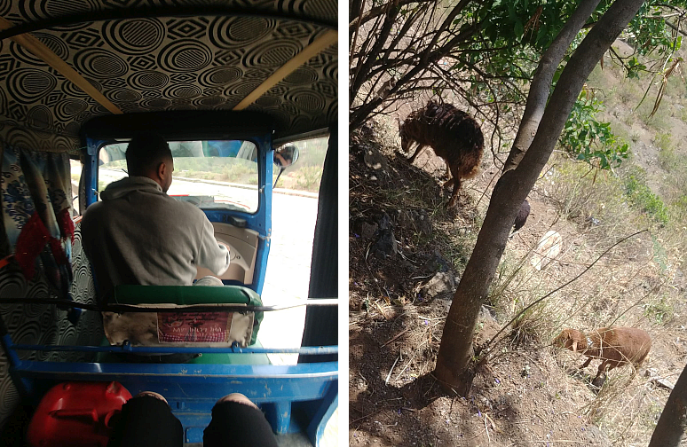
 | They were just hanging about near here:
Adriana Vera | 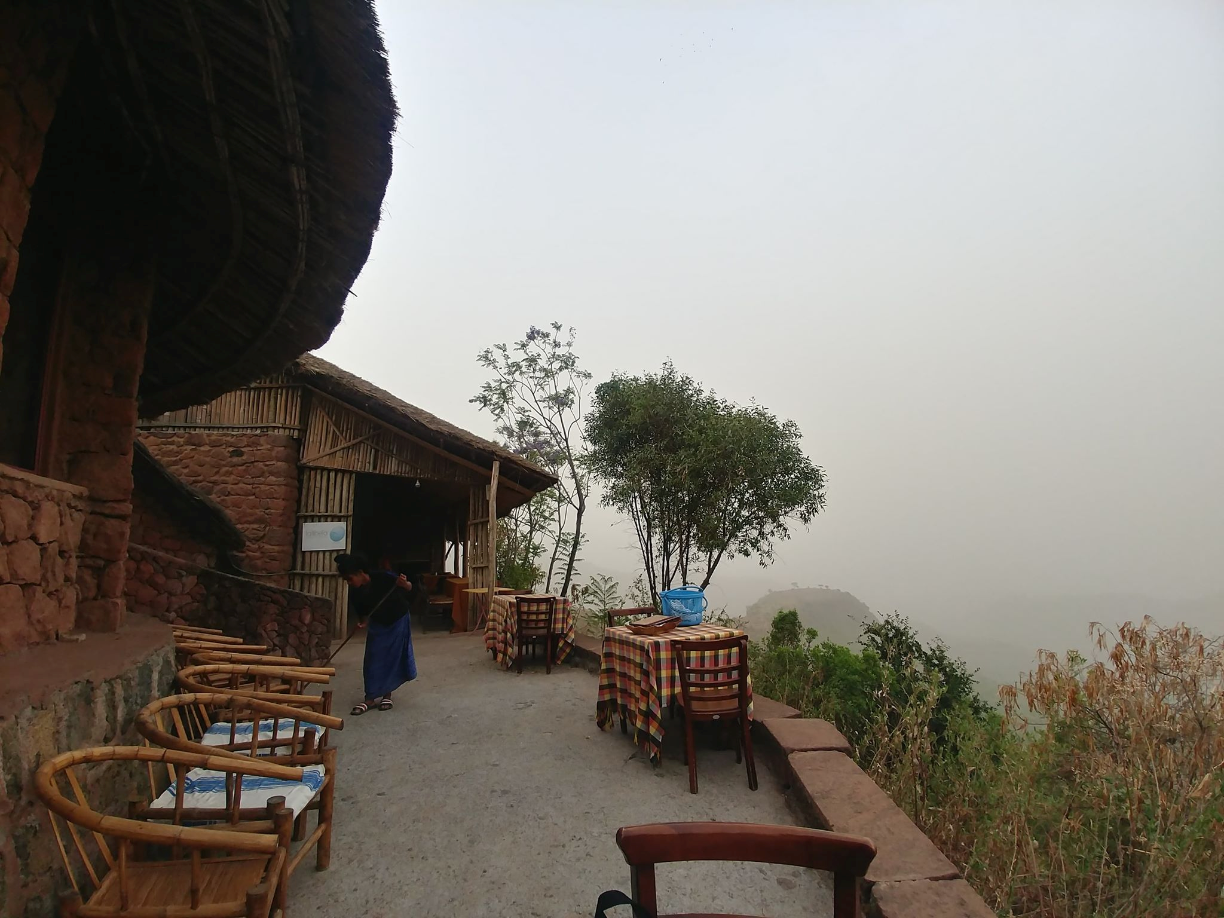
 | I hope to fly out tomorrow back to Addis. Other than the rock hewn churches, there isn't much activity here.
Taras Myron | Are you gonna swim with the whale sharks?
Adriana Vera | Nope. That's in Djibouti. I decided not to do that this time.  @Taras … are people working from home at GAC???
Natalia Anna | We have been given the option if we need to - but not told to. Yet
Tamara Pomac | Apparently a message will come today or tomorrow
Natalia Anna | For GAC Tamara?  Or for all federal employees to stay home?
Tamara Pomac | I think all departments are working on plans.
Adriana replied to Tamara | Ok. Thank you.
Natalia Anna | Yeah. Ours is come in unless you need to stay home or are sick.
Tamara Pomac | I don't know the details. Are you skeleton staff? I would guess that only skeleton staff will be working. This is an emergency.
Adriana Vera | My question was about GAC because of international travel etc. our situation is different
Tamara Pomac | Maybe other specific people to be told to work I'd they are essential bit I don't know - this is unprecedented so I'm just guessing.
Taras Myron | On Friday, the IT resource center was at full capacity dealing with clients who were borrowing loaner laptops, ensuring their remote tokens work properly, getting instructions on how to connect from home, etc.
Adriana replied to Tamara | Hell no! I am not skeleton staff! I’m a damn term. When the shit hits the fan, they better not pretend I'm all valuable and irreplaceable all of a sudden!!!
Adriana replied to Taras | Oyyyyy. I can imagine how busy it was!
Taras Myron | We haven't been told anything official, but were told to stay tuned for an announcement. Probably Sunday
Adriana replied to Taras | Good.
Taras Myron | We'll see how our current remote access infrastructure keeps up.... I bet there will be sweeping changes in how we work after this "hits the fan".
Adriana Vera | Thanks for the updates!
Adriana replied to Taras | Yes. At PSPC they're being told to work offline. The system isn't managing.....
Taras Myron | There was a town-hall meeting for all of GoC yesterday. They said we should be following HC guidelines now as the situation unfolds. The said there will not be a Government-wide decision, it is up to every department to decide how to proceed.
Adriana Vera | Ok. Got it
Taras Myron | I think they are reviewing the definition of a True "essential service" in this situation and will make decisions accordingly.  BTW - the casino is closed.
Adriana replied to Taras | Oh man. This is serious! | 
Natalia Anna | For Coast Guard employees working from home they are given shifts 6 to 2 or 2 to 10.  TB issues a federal wide statement late yesterday saying people can work from home if they need to but don’t have to. If you can go in - fine.
Adriana Vera | Ok. I'm off for dinner. Will check back in in 3 hours max
Taras Myron | Смачного! Don't rush!
Saturday, March 14th — Conversation begins at 1600
Nina Pomac | Adriana I just heard on the news that GoC is advising Canadians who are abroad and want to get back to Canada to do so ASAP while there are still flights
Tamara Pomac | I was wondering if they would do this. Ad do you have the numbers to contact travel???
Natalia Anna | 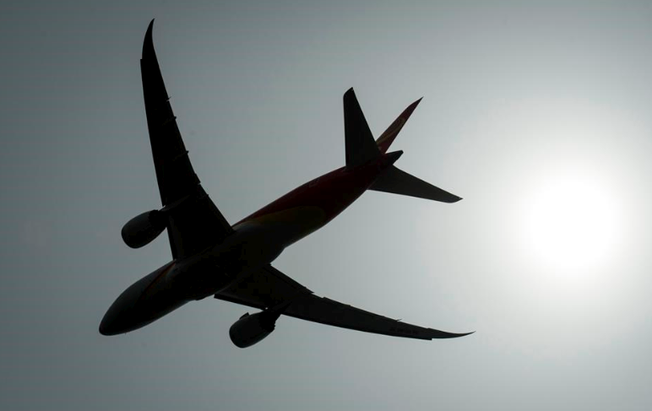  Canadians abroad recommended to return home while commercial means remain available - NEWS 1130  Canadians who are currently abroad are being told by the federal government to come back home while commercial planes are still available.  I think when you’re on travel status with the government, it might be a bit different. Will they not recall people officially?
Tamara Pomac | No I think that this applies to her now!  Her work is over and she can come home now.
Natalia Anna | Adi - keep us posted.
Tamara Pomac | I will ask Taras if he knows number to call from overseas.
Nina Pomac | Are you still in Lalibella?
Natalia Anna | Adi. Let us know your plan. And Rostyk too. So he can leave before you get home
Saturday, March 14th — Conversation begins at 1800
Adriana Vera | Hi everyone!  A lot has happened in the last day here. I am currently in Lalibela, scheduled to fly back to Addis Ababa tomorrow at 1PM. A dust storm has however travelled from Sudan and has caused massive visibility issues. Planes stopped flying last evening. It has been confirmed that our scheduled flight tomorrow will not fly, so we are hoping to fly out Monday from Lalibela.  If on Monday, planes still aren't flying, we will wait till evening and then, in consultation with the Embassy security team will arrange a vehicle to drive us the 14 hours back to Addis Ababa so I can make my 12:55 pm flight on Tuesday night.  Things are pretty fluid at the moment. The good news is that our hotel manager is very nice as are our rooms. It could be worse, right?!
Sunday, March 15th — Conversation begins at 0145
Natalia Anna | Keep us posted.
Sunday, March 15th — Conversation begins at 0445
Adriana Vera | Hi everyone. The fog/dust remains over Lalibela. We don't "think" our flight will fly today, but we don't have a full confirmation yet. Our team at the Embassy in Addis has been in touch and is making contingency plans. This is what the next few days may look like: We either get out of Lalibela via flight or via secure vehicle by Tuesday. When in Addis: Plan A: get on my scheduled Tuesday PM flight home via Istanbul. Plan B: get on a flight to London and stay with Neil until further notice.  The borders remain open and the UK has taken a "business as usual" approach, instead of an "isolation" approach. Plan C: Stay in Addis with a colleague until things settle or an embassy-wide plan is established. In this case, I would just do whatever they do. The preference for our security team is to get me out on my Tuesday flight.  But if airlines stop flying, it may be out of everyone's hands. Right now, I am sitting with my colleague in our almost empty lodge hotel, admiring the mountains.
Adriana Vera | As I may have told some of you, the Ethiopians have a very interesting belief that they are immune to Covid19. It is a white person’s illness. We have heard this from educated individuals which, at this stage of the game, is terrifying. There is no health system here. They're saying only 1 person in Ethiopia has Covid19 and that is a direct result of the severe lack of testing. I think that the profile of people who are most vulnerable to Covid19 infection is going to change drastically when it starts to spread here because we are not talking about a healthy population. We are talking about a population where everyone is malnourished, both young and old. So imagine what that is going to look like.  Another super interesting thing about Ethiopians is that they do not consider themselves as Africans! They are actually a middle eastern-African mix and believe they are superior to the African race as descendants of Solomon. They also believe that because of this they are somewhat "chosen"  And God will save them.
  Neil Littler | Thanks for the update. Stay safe and keep me posted!
Nina Pomac | Why is the hotel almost empty? Where are the other tourists?
Adriana replied to Nina | We think that tourists have organized cars/busses out. And also, no flights are coming in so the hotels aren't filling up.
Adriana Vera | Our flight today has been officially postponed to tomorrow. If it is cancelled again, we will drive tomorrow afternoon to another town (half way to Addis) sleep there, and then all the way to Addis on Tuesday AM. The embassy is preparing for flights to stop. That's why they're keen on getting us out and into Addis.  We have checked into a new hotel: Sora Lodge. We wanted a different view. Lol.  Check it out online: Sora Lodge, Lalibela.
Nina Pomac | Just try to stay safe!  It looks very nice; hopefully it’s very clean! Keep washing those hands!
Adriana Vera | We are safe. We are going to hang out at the hotel tonight. Hence why we changed hotels. This one has a bit more going on in terms of a restaurant, a sunset bar, etc.  New hotel pictures.
 | 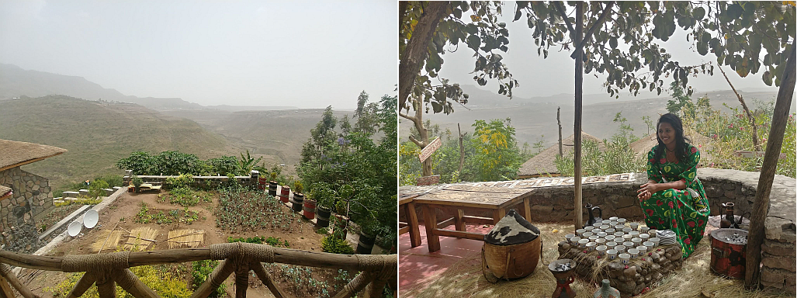
The view from my room. And then the woman doing a traditional coffee ceremony for us. So now we are sitting drinking coffee and eating popcorn.
Notice the vegetable garden in the view picture. I see parsley and I'm going to ask if i can pick some!!!!
You bet!
Neil Littler | Great view.
Adriana Vera | It is! It's very beautiful here! It's a nice place to get away to for 2 days. But other than the churches and the market, there's only the view to admire.  Quick update: all is well here. Our hotel is good and filled with Ferengi like us!  Everyone is asking the same questions!  And the embassy is preparing our plan by car outa here.
Nina Pomac | It’s probably just as well that you’re away from the bigger crowds of Addis Ababa, but still be very vigilant around the other guests. The same might apply for a car versus a plane ride. Just wipe down the hard surfaces around you (armrests, tabletops) where are the virus can live the longest. I’m sure you’re aware of all this but please do be careful! In other circumstances that hotel does look like a great escape!  The lady in the picture looks absolutely lovely in her beautiful dress!
  Anne-Marie | Hope it goes ok and you manage to get the car out of there. In the meantime, try and enjoy your visit.
Adriana replied to Nina | The lady in the picture looks absolutely lovely in her beautiful dress!  Mama - Yes! This is the Arabic influence. It is also the reason why Northern Ethiopians have such slim facial features
r  Adriana replied to Anne-Marie | Hope it goes ok and you manage to get the car out of there. In the meantime, try and enjoy your visit  I hope so too!!! We are ok here at this hotel. In fact, we are excellent here. They are the best hotel here I think.  Thank you all!!!  It is doubtful that we will leave by flight tomorrow. The dust is just blowing and blowing. We have confirmed our plan B!!!
Anne-Marie | Ok well at least there is a plan B!
Adriana Vera | We have a car that will come from Bahir Dar tomorrow as soon as we confirm.
Nina Pomac | Great! Hopefully this will start to move forward!
Adriana replied to Nina | Yes. This is most likely our solution and way forward.
Adriana Vera | It's starting to rain!!!  Holy guacamole!!
Tamara Pomac | Does rain mean that the dust might settle???
Adriana Vera | This was the rain. I hope it comes back.
Adriana Vera | 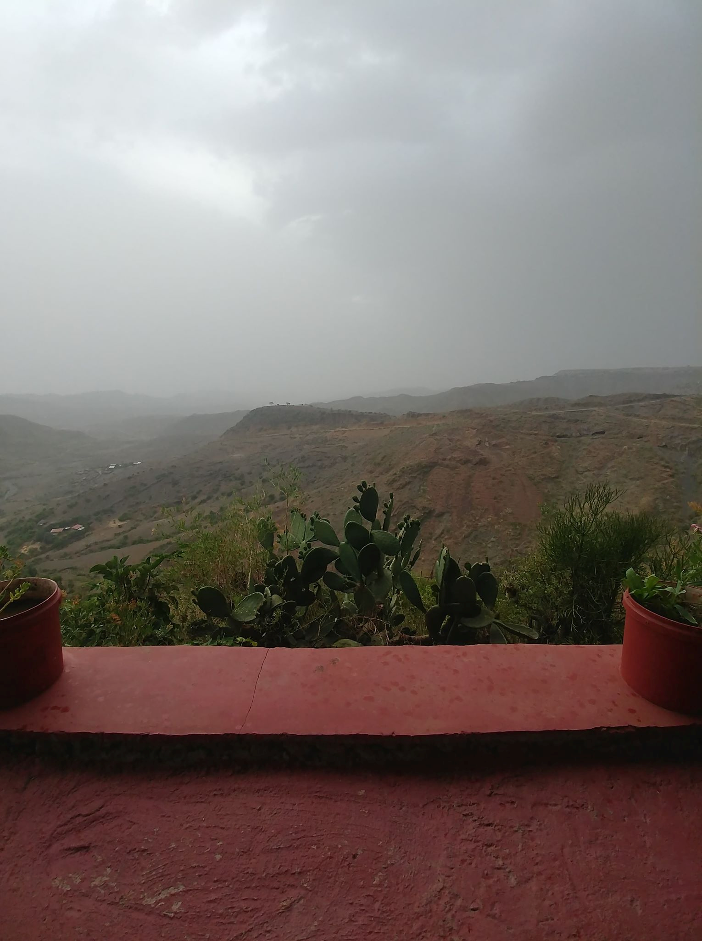
Anne-Marie | Wow
Tamara Pomac | That is great for them right since it is so dry.
Adriana replied to Tamara | That is great for them right since it is so dry.  Yes. And us too. It may settle the dust.  We may be able to fly!
Tamara Pomac | Keep us posted xo
Adriana Vera | You bet!
Taras Myron | Stay Healthy... wash your hands, stay hydrated, and get good SLEEP (at least try)...
Adriana Vera | It is raining!!!  Fingers crossed this calms the dust storms from Egypt/Sudan!
Neil Littler | Yay. Good news
Adriana Vera | In my life, I have never been this happy to see rain. Never.  It's raining. It's really raining!!!
Nina Pomac | Yeah!!!!!!!!!!!!!!!!!
Sunday, March 15th — Conversation begins at 1430
Nina Pomac | How long did it rain? Did it make a significant difference in the smog?
Adriana Vera | It is still drizzling.  We will see in the morning if it has changed the wind patterns. Fingers crossed!  We do have a car with a secure driver that will start travelling our way at 730AM tomorrow. He is in Bahir Dar which is 5 hours away. By 11am we will know if flights are back on, and if so, we will fly. If not, he will be here by 1PM and we will drive back to Bahir Dar tomorrow. We will spend the night there and the travel another 12-14 hours on Tuesday to get me to the airport on time.  The plan has been made.
  PaPa “Dave” | Thank God there is a plan / but what a plan!  Keep us posted please
Adriana replied to PaPa “Dave” | I know Dave! It isn't "simple" but it works.
Adriana Vera | One day, this will be quite the story!! One day. But not quite today, yet.
Nina Pomac | Yes, quite the story!!!  Fingers and toes crossed
Neil Littler | Wowzers. What's a journey!  Fingers crossed.
Anne-Marie | Good luck with it all.
Monday, March 16th — Conversation begins at 0030
Nina Pomac | Let me know when you know anything about your travel to Addis!!! Just going to bed in a few minutes
Adriana replied to Nina | Hi Mama!  The rains last night have settled the dust. We will be heading to the airport earlier than normal to make sure we have a boarding pass as soon as we know the incoming flight from Addis has departed.  Our driver has departed Bahir Dar for Lalibela just in case. We will call him off when we are confirmed to be flying.  It is about a 5 hour drive from Bahir Dar to Lalibela and we are not permitted to travel via vehicle after sunset which is why things are playing out the way they are with the driver.
Nina Pomac | Good luck with that flight! It would be so much easier, but If it means taking the car - anything that will get you home!
Adriana Vera | I hope we can fly. It's a much better option and the Embassy’s preferred option. 1.5 hours instead of 20.
Nina Pomac | Tsiom tsiom! Let us know when you’re confirmed, either way!!!!
Adriana Vera | You bet!!!  I will be very happy to get back to Addis today.
Nina Pomac | Let it be so!!! Do you have plane tickets from the cancelled flight or will you have to buy them on the spot?
Adriana Vera | Our original tickets were transferred to today’s flight. We just want to make sure we are on it as it will likely be overbooked.
Monday, March 16th — Conversation begins at 0415
Adriana Vera | Ok. It looks like we are going to fly! We will go to the airports in a half hour. The Embassy has also made a few calls to make sure we are on the flight and not bumped. It looks like the embassy will shut down by end of week so it is imperative that I be on my flight out of the country on Tuesday night. In other news, you may want to consider having cash at home. Like $1000 or so just in case ATMs run out and the banks stop filling them because everyone is in isolation. Better to be safe than sorry, I think.
Neil Littler | Great news!
Adriana Vera | At the airport with a boarding pass in hand!!!!
Neil Littler | Whoop Whoop!  What time is your flight?
Adriana Vera | Knows!!! Boarding!!! Love you all!!!
Natalia Anna | Hey, the official decision came down from treasury Board yesterday that employees should be working from home unless their managers require their presence in the office. I’m heading over to the office now to grab my screens and coming home
Nina Pomac | Hallelujah!!!!!!!!!! What a relief!!!!! Safe flight!!!
Natalia Anna | Are you still on schedule to be back Wednesday late? How are you getting to Ottawa??
Nina Pomac | Let us know how things look in Addis and what you are doing when you get a chance!
Adriana Vera | Will touch base again from the Ramada in Addis. I think they don't want me to come to the embassy tomorrow as I had planned to thank everyone for helping Kathie and me with this challenging situation. It sounds like they prefer that I concentrate on making it to the airport.  Bye-bye Lalibela!! Taking off now!!!
Monday, March 16th — Conversation begins at 0750
Adriana Vera | Landed in Addis!! Heading to the hotel now.  I'm back and checked into my hotel.  It's quieter here at the hotel for sure. Almost empty in fact.  I am hanging about here. I won't go out this evening. I will just relax in my room and catch up on my  TV – I mean emails. HaHaHa.
Neil Littler | Yay. Glad you are back!
Adriana Vera | Me too. Me too
Neil Littler | Yes enjoy some chill time  And order some wine!
Adriana Vera | Kathie and I got on that plane and both just signed a sigh of serious relief.  We will both sleep well tonight. By the way, Kathie is my colleague here at the embassy. We had never met, but I helped her with a few things from HQ over the last months. Normal stuff really. Turns out, she's Ukrainian and we know people in common. We decided we will travel again together but not in Africa. Hahaha. It's off our friend travel list.
Anne-Marie | Great news! Glad you back ok
Natalia Anna | Adi. Stay away from people!  Horrible ad it might sounds
Adriana Vera | I will.  Any updates on Bohdanchyk and how he us feeling????
Natalia Anna | Nope. They are going to get him tested at the COVID-19 Center this morning  Olive oil or avocado
Monday, March 16th — Conversation begins at 0940
Adriana Vera | Just a confirmation to all that I am flying at 1:45AM on Wednesday March 19. All other flights are full!  We thought perhaps I could hop an earlier flight but no such luck.
Natalia Anna | Ok. Stay healthy.
Monday, March 16th — Conversation begins at 1335
Natalia Anna | If you can find a place to stream it, the Prime Minister will be giving a speech anytime now.  I will tell you what he says just in case you can’t.  We are officially closing boarders to everyone who is not a citizen or a permanent resident  Air crew, American citizens, and Diplomats  Canadians who show any symptoms will be denied entrance to the country.  Those who do not have symptoms will be asked to self-isolate  Flight crews will identify anyone on flights who is showing symptoms to CBSA  There is a new support program being set up to help Canadian citizens abroad get home.  Vancouver, Calgary, Toronto, and Montreal are the only airports that will be accepting international flights as of Wednesday morning
Tamara Pomac | Where do you arrive to Ad? Which airport?  We are watching the footage as Nat mentioned above.  Just don't get sick Ad!!! Stay in your room, wash hands and stay healthy.
Natalia Anna | She flies into Montreal. BUT. Maybe someone should pick her up!!! The train is a bad idea.
PaPa “Dave” | I can do that. I took Tuesday through Thursday off work because Katrina and Ashley we’re going to visit but that visit is off thanks to COVID-19  It would be my pleasure to act as a chauffeur
Adriana replied to PaPa “Dave” | Thanks Dave! I will self-isolate straight from the airport. My car will be waiting thanks to Mum and Tamara.
Tuesday, March 17th — Conversation begins at 0655
Adriana Vera | 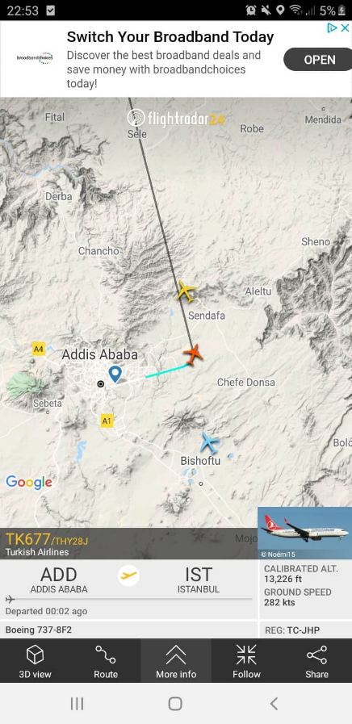  Its wheels-up for Istanbul!  The airport is quiet. Lots of planes that are sitting. And lots of people sleeping around the airport. These are the cancellations for today.  I fly into Ottawa via Toronto. Mama and Tam are parking my car at the airport on Wednesday and I'll drive myself home
Nina replied to Natalia | Nat, she flies into Toronto
Wednesday, March 18th — Conversation begins at 0035
Adriana Vera | I'm in Istanbul! It was an uneventful flight but not a comfortable one. I think I can safely say I was exhausted and still am.  The airport is quiet. Lots of planes that are sitting. And lots of people sleeping around the airport. These are the cancellations for today.
 | 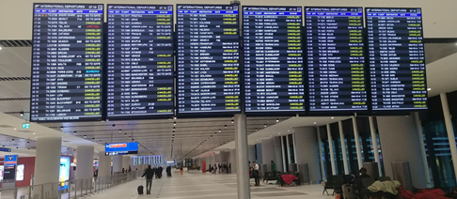
Anne-Marie | Oh my goodness!  Glad you made it to Istanbul
Adriana Vera | Me too!  I am having a glass of wine FINALLY feeling confident like home is near!
Anne-Marie | Will be such a relief to get on that final flight! What a mission!
 | What a mission is right. I may need a break after this.
Natalia Anna | You’ll have a two week break. It’s called self-isolation! I’m heading to the grocery store to stock you up!
Wednesday, March 18th — Conversation begins at 0910
Adriana Vera | Just a heads up!! We are already flying home!! The sense of relief is overwhelming. The discussion on the plane is that this is Turkish Airways last flight to Canada and that Turkey will announce closure of its borders shortly, effective midnight tonight.  I am more relieved than I can explain. I knew this mission would be difficult going into it. Corona Virus added a whole other level of difficulty, challenge, and uncertainty. I am SO happy to be coming home. Looking forward to facetiming each of you from isolation!!! Now I'm having a glass of Champaign and watching a movie because WHY NOT!!
Anne-Marie | Yay! Thank goodness you made it!
Tamara Pomac | Wow!!! You must feel so relieved!!! XOXO
Adriana Vera | I am more relieved than I can explain. I knew this mission would be difficult going into it. Corona Virus added a whole other level of difficulty, challenge and uncertainty. I am SO happy to be coming home.
Adriana Vera | Looking forward to facetiming each of you from isolation!!!  Now I'm having a glass of Champaign and watching a movie because WHY NOT!!
Anne-Marie | 
Wednesday, March 18th — Conversation begins at 1610
Nina Pomac | Taras and I emptied Costco this morning! Phew ... none of us will starve!
Natalia Anna | Adi. You have internet on the flight?  I left you a welcome home gift on your kitchen table.
Adriana Vera | I really hope it isn't a 24 of corona beer?!
Natalia Anna | Oh my god.  I wish I had thought of that... lmfao!!!!  They would have been amazing.  Nope.
Wednesday, March 18th — Conversation begins at 2050
Adriana Vera | I've landed in Toronto and am now awaiting my final flight.
Tamara Pomac
Natalia Anna | You got through CBSA OK?
Tamara Pomac | Suuuuper news Ad! Must have been awesome to see our border guards!!!
Adriana Vera | CBSA was very casual. My feeling is that because there is no official quarantine, they can’t do much.
Anne-Marie | Yay, back in Canada!
Natalia Anna | They didn’t give you information about self-isolating? Or ask any questions about your health?
Adriana Vera | Like, they're relying on self-isolation and self-reporting. So even if you had a fever, what authorities do they have? I believe none. So they weren't even checking body temperature.
Natalia Anna | Actually, I believe that if you declared that you had a fever they would need to isolate you right away. It was something that the Prime Minister said yesterday.
Adriana replied to Natalia | Yes. I got 2 handouts and they asked if I had cough, fever, or sore-throat.
Natalia Anna | Ok.  Lol
Adriana replied to Natalia | There you go. We aren't there yet.
Natalia Anna | I’ll give it until the weekend, and then we will be.
Tamara Pomac | Welcome home Ad!! Sooo glad you are here now! XO
Nina Pomac | Welcome home Adriana!!!! We’re heading out to bring your car to the airport. You have car keys right? I’ll send you info about where we park. How are others going home? Anyone taking taxis?
Adriana Vera | I think others may take a taxi. I'm not risking it. I’ve been on so many flights and have net so many people that I should be as careful as possible. I have keys, yes.  Mum - can you leave the big key for the front building door in the car, please???
  Sarah Emelie | Welcome home!!! Glad you made it back on Canadian sooo safe and sound.
Nina Pomac | I didn’t see that message about the big key. just call me when you get to your car and I’ll meet you at your house! I want to see you anyway!!!!
Natalia Anna | Mama.  That is not the best idea.  Self-isolation is being required for a reason
Tamara Pomac | 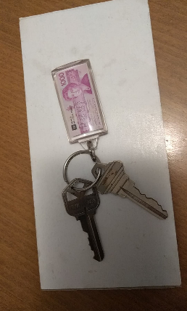  We also must have a key at our place...let me just look.  Ad - are your keys the ones on the $1000 keychain???  Ok I am not sure if these are your keys but they are the only ones hanging here that I don't know what they are...so, I am going to leave them in our mailbox. Going to sleep soon. Will send a picture in a second...
Natalia Anna | I don’t think those are Adrianna’s keys. I think I thought that they were from up north and brought them to you.
Tamara Pomac | Ugh ok.  I'm putting them in mailbox just in case because I haven't hear from ad and she will know. Sorry for all the messages ad!
Nina Pomac | Ok enough, stand down. Watching a movie and in about half an hour I’ll get in my car, drive over to her parking lot. When she arrives I’ll put the key on the step, get back in my car and leave. I will NOT hug her or even go near her or anything. Please A nap in the afternoon and I’m wide awake watching a movie. That’s It and that’s al
Tamara Pomac | Dobranich! XO
Nina Pomac | Thank you! This is a no brainer.
Adriana Vera | Nope. I can let myself in with my phone. Don't worry about it Mama!
Tamara Pomac
Nina Pomac | How is that even possible?
Natalia Anna | She presses her buzzer which is linked to her cell phone, which will ring, and then she will let herself in pressing nine or zero or whatever number it is there.
Thursday, March 19 — 0110
Adriana Vera | Home!
  Susan | Happy you are home!!
Adriana Vera | Thank you, Toitia Svetlana!! It's great to be home
Susan | 

