Commemorating Ukraine’s Great Lion
now closer to sainthood
Father Raymond J. de Souza | July 27, 2015 4:26 PM ET
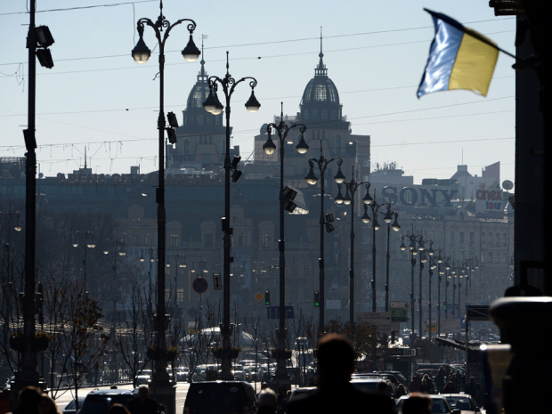
VASILY MAXIMOV/AFP/Getty Images A general view shows Khreshchatyk, main street of Kyiv, on October 27, 2014. Ukraine's pro-Western and moderately nationalist parties were on course Monday to score a crushing election win that boosted President Petro Poroshenko's bid to lead his country closer to Europe and end a pro-Russian revolt.
L’viv, UKRAINE — Wednesday this city will mark the sesquicentennial birthday of what some Ukrainian Catholics are not abashed to call their Moses, one of the great lions of the 20th Century, Andrey Sheptytsky. On the day I arrived, the Ukrainian Greek Catholic Church (UGCC), which he led for 44 years, rejoiced at the news that the Vatican had published a decree declaring him worthy of sainthood. Much deserved and much delayed, the decree comes just in time for Wednesday’s commemoration of his birth on July 29, 1865, during which a major monument will be erected in a civic park across from St. George’s cathedral where he is buried.
Andrey Sheptytsky, 1865-1944, experienced firsthand why the vast territories between Moscow and Berlin have been called “the bloodlands.” Indeed, to know Sheptytsky — and his memory is kept vibrant at the Sheptytsky Institute at St. Paul University in Ottawa — it is necessary to understand the great and wicked forces unleashed upon the peoples of eastern and central Europe with lethal ferocity in the 20th Century.
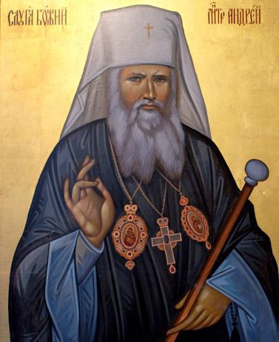
During the 19th Century, neither Poland nor Ukraine existed on the map of Europe, the future “bloodlands” having been carved up between the Austrian, Prussian, and Russian empires. Galicia, today divided between Poland and Ukraine, was largely held by the Habsburgs of Vienna, with its two principal cities, Krakow in the west and L’viv in the east, reflecting both in their architecture and outlook their belonging to the heart of Europe.
Sheptytsky was born into a noble Polish family, but discovered in his ancestors the tradition of the UGCC — Catholics fully united with Rome but maintaining the liturgy and governance of the Greek tradition of Constantinople. As a young man, Sheptytsky, contrary to his father’s wishes, opted for his Ukrainian heritage, becoming a monk in the UGCC. In 1900, at the young age of 35, he was made a bishop and soon after the metropolitan of L’viv, head of the UGCC.
As leader of the largest of the eastern Catholic churches — some 5 million souls — Sheptytsky had to lead a people without a nation. Not belonging to the empires that threatened from every side, and insisting on his Ukrainian nationality and his Catholic faith, Sheptytsky would find himself maltreated by almost everyone.
During the Great War, as the Tsar advanced against the Hapsburgs, Sheptytsky was imprisoned for opposing the Russification of L’viv and Ukraine. After the war, with the dissolution of the Russian, Prussian and Austrian monarchies, Poland and Ukraine were returned to sovereign existence. That freedom was brief, and Russia unsuccessfully tried to take Poland in 1919/1920. It did take Ukraine, incorporating it into the new Soviet Union.
Sheptytsky then found himself in mortal combat with the evil empire, attempting to keep alive a Ukraine in the face of Moscow, and the Greek Catholic tradition in the face of the hostile Moscow Patriarchate of the Russian Orthodox Church. The Holodomor terror famine visited upon Ukraine by Stalin was the bloodiest of a litany of assaults.
After nearly two decades of Soviet brutality, when the Nazis arrived to “liberate” L’viv and Ukraine in 1941, Sheptytsky initially welcomed them. He soon saw through their lies, and in opposing them, faced Nazi house arrest. Heroically, in his residence across from St. George’s Cathedral, he sheltered hundreds of Jews from the Holocaust at great personal risk.
He died on Nov. 1, 1944, with the Red Army once again occupying L’viv. He had seen to his successor in consecrating Josyf Slipyj a bishop. He predicted that Stalin would seek the total annihilation of the UGCC. With the mighty patriarch dead, Stalin did just that, liquidating the UGCC and sending Slipyj to 18 years of hard labour in the Siberian gulag.
But before that, in 1928, Sheptytsky had started the L’viv Theological Academy to invigorate Ukrainian Catholic letters and culture. Slipyj was its first rector. Today, in an independent Ukraine, the Ukrainian Catholic University is established and thriving, one of the few academic institutions entirely free of the corruption rampant in the post-Soviet statist universities. The students who study here have had their freedom bought at a very great price.
Slipyj, who died in Roman exile, is now buried beside Sheptytsky. To pray at their graves is to praise God that the great lions were stronger than the empires which sought to crush them. They are heroes of Ukrainian patriotism, and heroic witnesses of Catholic faith. Their witness is needed today, for Ukraine is again under attack, with Russia occupying its eastern regions and having annexed Crimea.
There are several ways to write and pronounce the name of this city, depending on language and history. I prefer the Latin — Leopolis — city of the lion. When Sheptytsky lived, it was.

